Name:____________________________________________________ Date:______

Entrance Sign Exam
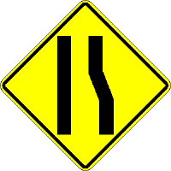
- Right lane ends
- Crooked lanes ahead
- Intersection ahead
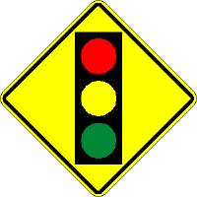
- Stop ahead
- Traffic signal ahead
- Intersection ahead

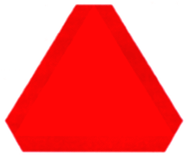
- Construction
- Severe warning ahead
- Slow moving vehicle
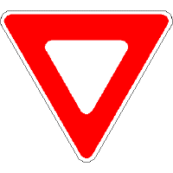
- Stop ahead
- Yield
- Construction
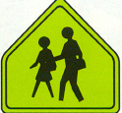
- Children playing
- Playground
- School zone
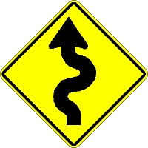
- S curve ahead
- Slippery road ahead
- River ahead
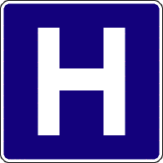
- Handicapped
- Hospital
- Information
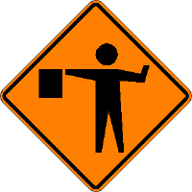
- Stop ahead
- Construction worker ahead
- Pedestrian crossing
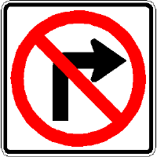
- No road on the right
- No right turn
- Right turn only
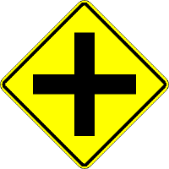
- Stop ahead
- 4-way Intersection ahead
- Crossing guard ahead

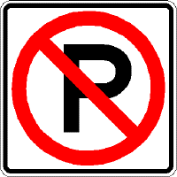
- No Parking
- Pedestrians not allowed
- No pool

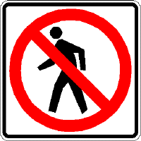
- Pedestrians not allowed
- No Crosswalk
- No trail
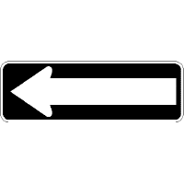
- Parking to the left
- One way
- No right turn
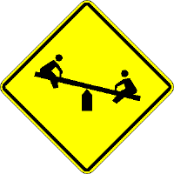
- Playground ahead
- School zone
- No children allowed
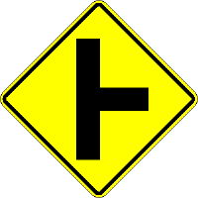
- Intersection ahead on right
- Public transportation
- Right turn only
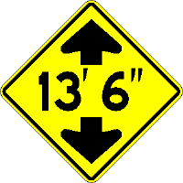
- Intersection ahead at 13’ 6”
- Height clearance of 13’ 6”
- Road ends in 13’ 6”
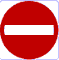
- Red Cross
- Do not enter
- Hospital

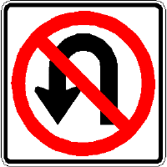
- No U-turn
- Straight road
- No backing up
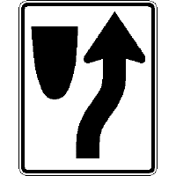
- Keep to the right of median
- No right turn
- Right turn only
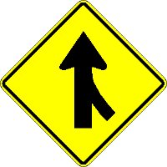
- Traffic entering from the right (Merge)
- Intersection ahead
- No right turn

